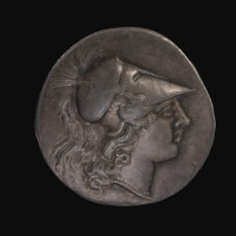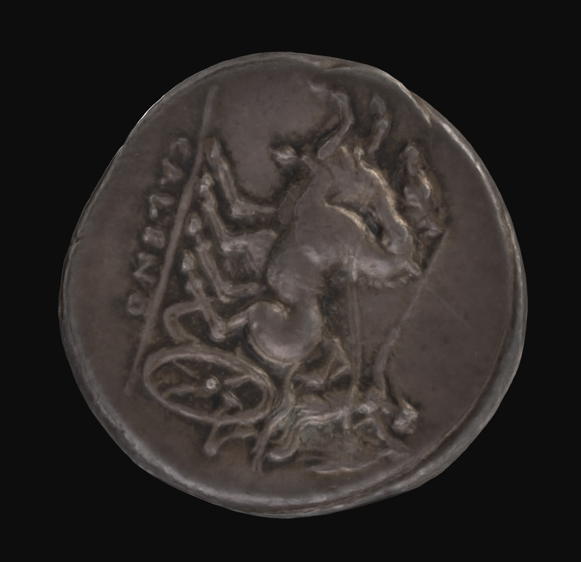

**Minerva Bigati Didrachm:**

*This didrachm (07GS0029) was issued by and minted in Cales, Campania, between 265 and 240 BCE. The obverse depicts the bust of Minerva, facing right, wearing a crested Corinthian helmet decorated with a pentagram, with a wing behind her head. Minerva, the Roman goddess of wisdom in defensive military strategy and craftsmanship, played a major role in the Roman Republic, who viewed themselves as only fighting in wars in defense. The reverse of the coin depicts Nike, the goddess of victory, as a bigarius, driving a two-horsed biga (chariot), with the inscription below referencing the coin's city of origin - ‘CALENO’. Nike was often worshipped alongside Minerva, which may be a reflection of the Hellenic influence within the city due to its proximity to Magna Graecia, stemming from the worship of Athena Nike during periods of* *war.*

**The First Punic War (264 BCE - 241 BCE) → Close Passage**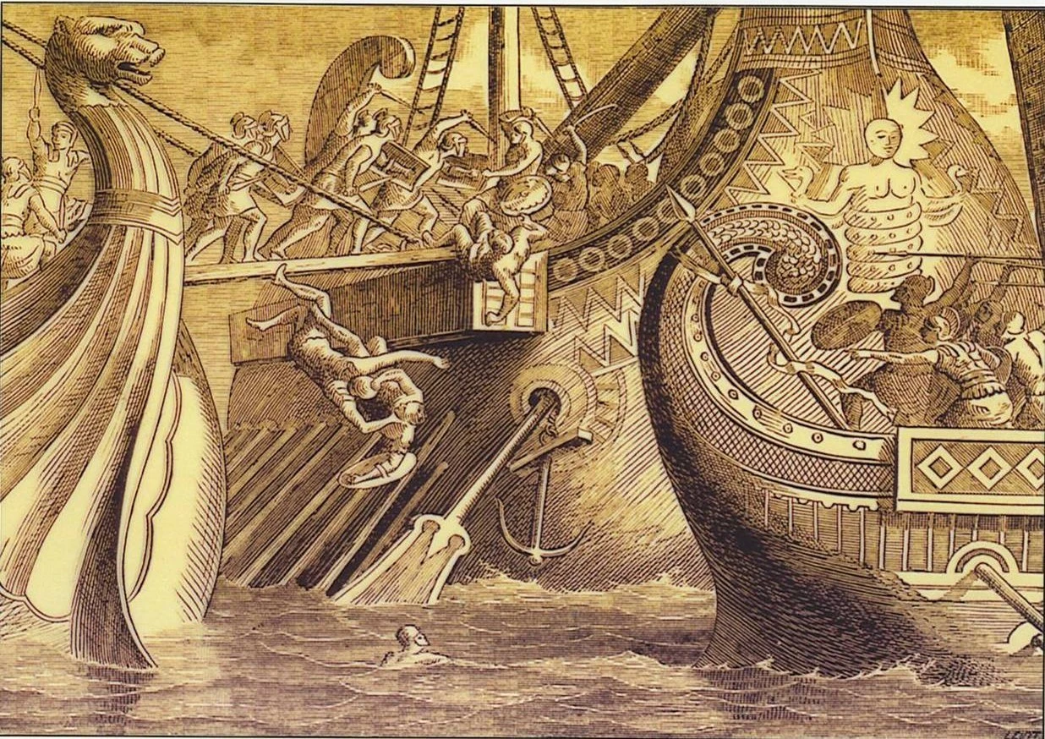

The First Punic War was fought between the two major powers of the Mediterranean in the 3rd century BCE, _____ and Carthage. The war was over control of Sicily and Corsica, strategic islands which were major sources of commerce and grain. This was the first expansionist war of Rome that took place outside the Italian peninsula. Carthage, by establishing a ______ presence on the islands, encroached on Roman territory. This led to the outbreak of war.

At this point in time, Carthage was a well-established naval superpower, and controlled most of the trade within the _________ Sea. They had also established many colonies, which made their presence in _____ much more threatening to the Roman Republic. Rome, however, had recently expanded into Magna _____, which occupied the southern peninsula. This concerned Carthage, as they had been contending with the Greeks for control over Sicily for years. Rome was inexperienced in naval combat, and due to difficulties moving troops inland in Sicily, most of the major battles were fought at ___. This put Rome at a noticeable disadvantage.

The Carthaginians supported Syracuse, who were fighting Messana, and held the city under ____. In response, Rome sent 16,000 troops, which managed to break the siege overnight, defeating both the ________ and Carthaginians. This led to Syracuse’s surrender and _______ with Rome in 263 BCE, and many other cities in Sicily followed suit. Rome sent consuls into these cities, accompanied by _____, in order to bolster the military of the island. However, Carthage was still determined to be victorious, and sent more fleets to the city of Agrigentum, which became the Carthaginian hub in Sicily.

The Battle of _______ in 262 BCE was the first major battle between the two powers, and saw a Roman victory. It was after this battle, and other smaller naval skirmishes, that Rome felt it needed a stronger ___ if it wanted to rout Carthage from Sicily. In 260 BCE, Rome used captured Carthaginian ships as a ______ for their own navy, creating a fleet of 20 triremes (three-levelled ships) and 100 quinqueremes (five-levelled ships).

In traditional Roman fashion, they innovated. They created a rotating, spiked platform, called a corvus, which could latch onto enemy ____, allowing infantry to board. This made naval combat more like ____ combat, which Romans were much more comfortable with. However, its uneven weight led to the _____ of many Roman ships. Despite this, in the same year, Rome defeated _____ at the Battle of Mylae, which marked their first naval victory in history.

Eventually, in 241 BCE, Rome defeated Carthage at Drepana, a besieged city on an island off the coast of Sicily. Though the losses were not immense, the extended financial toll of the war caused Carthage to seek ____ terms, including their retreat from Sicily, and the payment of reparations to Rome.

|  |  |  |  |  |  |
| --- | --- | --- | --- | --- | --- |
| **Word Bank** | | | | | |
| Sicily | vessels | Graecia | legions | Mediterranean | peace |
| navy | land | Syracusans | Agrigentum | military | siege |
| sinking | sea | Rome | blueprint | Carthage | alliance |